Q1.
A swimming pool is being filled with water.
(a) Calculate the weight of the water in the swimming pool when the mass of the water is 25 000 kg.
gravitational field strength = 9.8 N/kg
Use the equation:
weight = mass × gravitational field strength
___________________________________________________________________
___________________________________________________________________
___________________________________________________________________
Weight = ____________________N
(2)
(b) When the swimming pool is full, the weight of the water is 1 960 000 N.
The bottom of the swimming pool has an area of 49 m².
Calculate the pressure at the bottom of the swimming pool when it is full.
Use the equation:
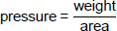
Choose the unit from the box.

m² | m³ | N | Pa
___________________________________________________________________
___________________________________________________________________
___________________________________________________________________
___________________________________________________________________
___________________________________________________________________
Pressure = ____________________ Unit __________
(3)
(c) There is a force acting on the side of the swimming pool because of the water pressure.
Figure 1 shows the side of the swimming pool.
Figure 1
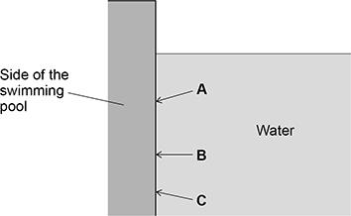
Which arrow shows the direction of the force acting on the side of the swimming pool?
Tick (✓) one box.

A |  | B |  | C
(1)
(d) A child is swimming in the pool. The velocity of the child is 0.70 m/s.
The child then accelerates for 5.0 s, reaching a final velocity of 1.3 m/s.
Calculate the acceleration of the child.
Use the equation:

___________________________________________________________________
___________________________________________________________________
___________________________________________________________________
Acceleration = ____________________ m/s²
(2)
Figure 2 shows a diving board at the side of the swimming pool.
Figure 2
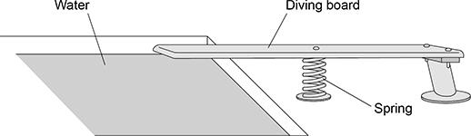
(e) The original length of the spring is 0.84 m.
When the child stands on the diving board, the length of the spring decreases by 0.21 m.
Calculate the percentage change in the length of the spring.
___________________________________________________________________
___________________________________________________________________
___________________________________________________________________
Percentage change in length = ____________________ %
(2)
Use the Physics Equations Sheet to answer parts (f) and (g).
(f) Write down the equation which links extension (e), force applied to a spring (F) and spring constant (k).
___________________________________________________________________
(1)
(g) The force applied to the spring by the weight of the child is 336 N.
The change in length of the spring is 0.21 m.
Calculate the spring constant of the spring.
___________________________________________________________________
___________________________________________________________________
___________________________________________________________________
___________________________________________________________________
___________________________________________________________________
Spring constant = ____________________ N/m
(3)
(h) The child steps off the diving board and falls into the swimming pool.
The initial velocity of the child is 0 m/s.
acceleration due to gravity = 9.8 m/s²
Calculate the final velocity when the child has fallen a distance of 0.95 m through the air.
Give your answer to 2 significant figures.
Use the Physics Equations Sheet.
___________________________________________________________________
___________________________________________________________________
___________________________________________________________________
___________________________________________________________________
___________________________________________________________________
___________________________________________________________________
___________________________________________________________________
Final velocity of child (2 significant figures) = ____________________ m/s
(4)
(Total 18 marks)
Q2.
Figure 1 shows an athlete on starting blocks waiting to start a 100 metre race.
Figure 1
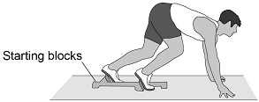
(a) Complete the sentence.
Choose the answer from the box.

equal to greater than less than
The force from the athlete pushing backwards on the starting blocks
is ________________________________ the force from the starting
blocks pushing forwards on the athlete.
(1)
Figure 2 shows a distance-time graph for the athlete from the moment the race starts.
Figure 2
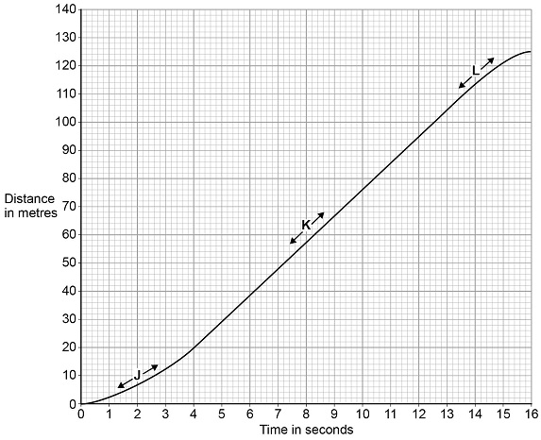
(b) Three parts of the distance-time graph are labelled J, K and L.
Draw one line from each of the labels to the correct description of the athlete’s motion for that part of the graph.
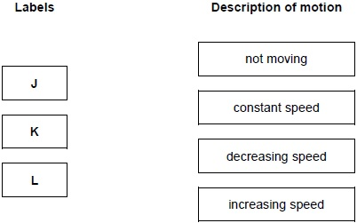
(2)
(c) What distance does the athlete travel after the end of the race before stopping?
Distance = ____________________________ m
(1)
(d) Calculate the average speed of the athlete between the start and finish of the 100 metre race.
Use the equation:
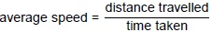
___________________________________________________________________
___________________________________________________________________
___________________________________________________________________
Average speed = __________________________ m/s
(2)
(e) The athlete runs faster than a typical person.
What is the average running speed of a typical person in metres per second?
Tick (✓) one box.

1.5 | 
3.0
4.5
6.0
(1)
(Total 7 marks)
Q3.
Some students designed and built an electric-powered go-kart.
The go-kart is shown below.
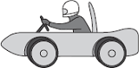
(a) Suggest two changes that could be made to the design of the go-kart to increase its top speed.
1. _________________________________________________________________
___________________________________________________________________
2. _________________________________________________________________
___________________________________________________________________
(2)
(b) A go-kart with a new design is entered into a race.
The velocity-time graph for the go-kart, during the first 40 seconds of the race, is shown below.
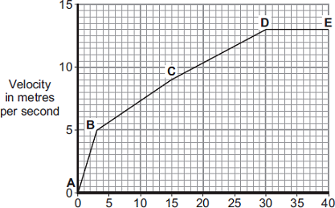
Time in seconds
(i) Between which two points did the go-kart have the greatest acceleration?
Tick ( ) one box.

A–B | 
B–C
C–D
Give a reason for your answer.
______________________________________________________________
______________________________________________________________
(2)
(ii) The go-kart travels at a speed of 13 m/s between points D and E.
The total mass of the go-kart and driver is 140 kg.
Calculate the momentum of the go-kart and driver between points D and E.
______________________________________________________________
______________________________________________________________
Momentum = _________________________ kg m/s
(2)
(Total 6 marks)
Q4.
(a) The diagram shows two forces acting on an object.
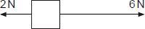
What is the resultant force acting on the object?
Tick ( ) one box.
8 N to the right
8 N to the left
4 N to the right
4 N to the left
(1)
(b) BASE jumpers jump from very high buildings and mountains for sport.
The diagram shows the forces acting on a BASE jumper in flight.
The BASE jumper is wearing a wingsuit.
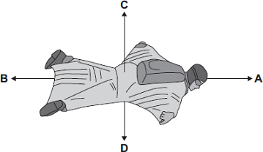
(i) Draw a ring around the correct answer in the box to complete each sentence.
The BASE jumper accelerates forwards when force A

 | smaller than
is | equal to | force B.
 | bigger than
The BASE jumper falls with a constant speed when force C

 | smaller than
is | equal to | force D.
 | bigger than
(2)
(ii) To land safely the BASE jumper opens a parachute.
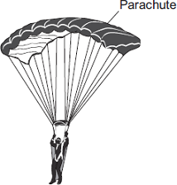
What effect does opening the parachute have on the speed of the falling BASE jumper?
______________________________________________________________
Give a reason for your answer.
______________________________________________________________
______________________________________________________________
(2)
(Total 5 marks)
Q5.
Figure 1 shows the velocity-time graph for a car driven along a straight road.
Figure 1
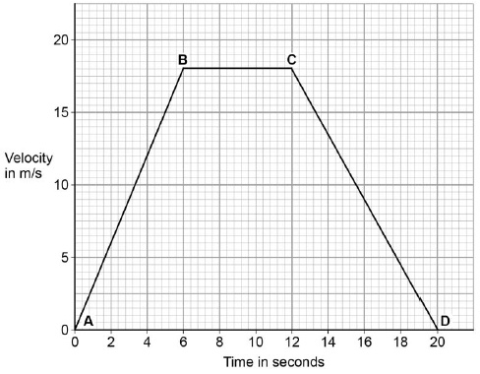
(a) From B to C the car is moving at a constant velocity.
Complete the sentence.
Choose the answer from the box.

equal to | greater than | less than
From B to C the forward driving force is _________________________ the
backward resistive force.
(1)
(b) From C to D the car is slowing down.
What word is used to describe the motion of an object that is slowing down?
___________________________________________________________________
(1)
(c) Between A and B the car is accelerating.
Calculate the acceleration of the car between A and B.
Use the equation:
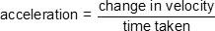
___________________________________________________________________
___________________________________________________________________
___________________________________________________________________
Acceleration = ____________________ m/s²
(2)
(d) Figure 2 shows how the stopping distance of a car depends on the speed of the car.
Figure 2
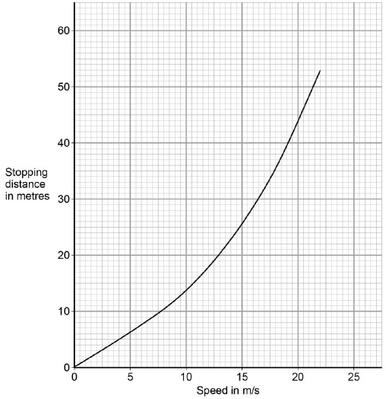
Describe what happens to the stopping distance of the car when the speed of the car doubles.
___________________________________________________________________
___________________________________________________________________
___________________________________________________________________
___________________________________________________________________
(2)
(Total 6 marks)
Q6.
A child drops a ball.
The ball hits the ground and bounces.
The graph below shows the velocity-time graph for the ball from when the ball is dropped until when the ball reaches the top of its first bounce.
Air resistance has been ignored.
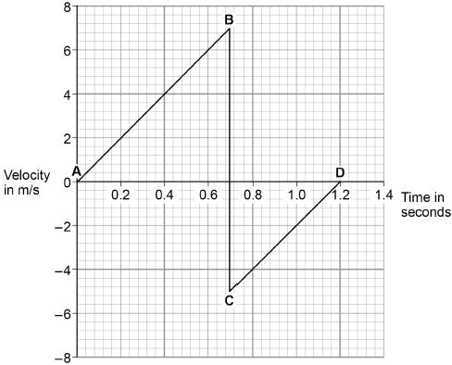
(a) Describe the motion of the ball between points A and B on the graph above.
___________________________________________________________________
___________________________________________________________________
___________________________________________________________________
___________________________________________________________________
(2)
(b) What direction is the ball moving between points C and D on the graph above?
___________________________________________________________________
(1)
(c) The ball and the Earth form a system.
What is meant by ‘a system’?
Tick one box.

A group of objects that interact.
Objects with big differences in mass.
Objects with gravitational potential energy.
(1)
(d) When the ball hits the ground, energy is transferred from the ball to the Earth.
Explain how the data in the graph above shows this energy transfer.
___________________________________________________________________
___________________________________________________________________
___________________________________________________________________
___________________________________________________________________
___________________________________________________________________
___________________________________________________________________
___________________________________________________________________
___________________________________________________________________
___________________________________________________________________
___________________________________________________________________
(4)
(Total 8 marks)
Q7.
(a) A person takes their dog for a walk.
The graph shows how the distance from their home changes with time.
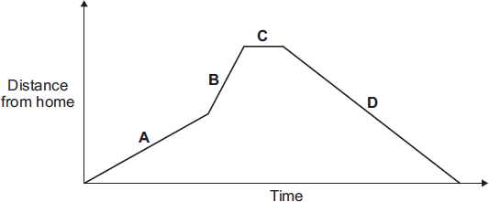
Which part of the graph, A, B, C or D, shows them walking the fastest?
Write your answer in the box. 
Give the reason for your answer.
___________________________________________________________________
___________________________________________________________________
(2)
(b) During the walk, both the speed and the velocity of the person and the dog change.
How is velocity different from speed?
___________________________________________________________________
___________________________________________________________________
(1)
(Total 3 marks)
Q8.
A cyclist travelling along a straight level road accelerates at 1.2 m/s² for 5 seconds.
The mass of the cyclist and the bicycle is 80 kg.
(a) Calculate the resultant force needed to produce this acceleration.
Show clearly how you work out your answer and give the unit.
___________________________________________________________________
___________________________________________________________________
Resultant force = ______________________
(3)
(b) The graph shows how the velocity of the cyclist changes with time.
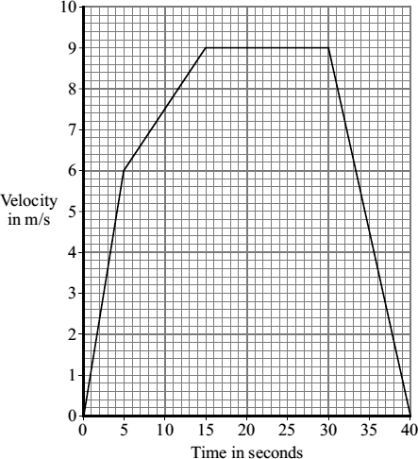
(i) Complete the following sentence.
The velocity includes both the speed and the _____________ of the cyclist.
(1)
(ii) Why has the data for the cyclist been shown as a line graph instead of a bar chart?
______________________________________________________________
______________________________________________________________
(1)
(iii) The diagrams show the horizontal forces acting on the cyclist at three different speeds. The length of an arrow represents the size of the force.
A  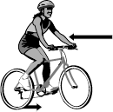 | B  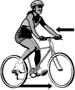 | C  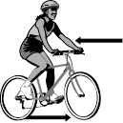
Which one of the diagrams, A, B or C, represents the forces acting when the cyclist is travelling at a constant 9 m/s?
______________________________________________________________
Explain the reason for your choice.
______________________________________________________________
______________________________________________________________
______________________________________________________________
______________________________________________________________
______________________________________________________________
______________________________________________________________
(3)
(Total 8 marks)
Q9.
(a) The diagram shows the horizontal forces that act on a moving motorbike.
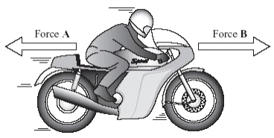
(i) Describe the movement of the motorbike when force A equals force B.
______________________________________________________________
______________________________________________________________
(2)
(ii) What happens to the speed of the motorbike if force B becomes smaller
than force A?
______________________________________________________________
(1)
(b) The graph shows how the velocity of a motorbike changes when it is travelling along a straight road.
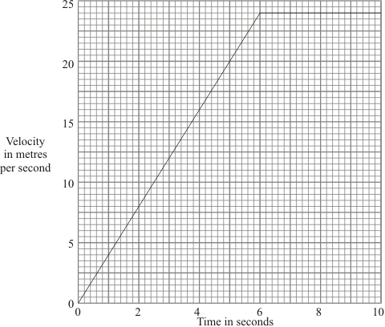
(i) What was the change in velocity of the motorbike in the first 5 seconds?
______________________________________________________________
(1)
(ii) Write down the equation which links acceleration, change in velocity and time taken.
______________________________________________________________
(1)
(iii) Calculate the acceleration of the motorbike during the first 5 seconds.
Show clearly how you work out your answer and give the unit.
______________________________________________________________
______________________________________________________________
Acceleration = _______________________
(3)
(c) A car is travelling on an icy road.
Describe and explain what might happen to the car when the brakes are applied.
___________________________________________________________________
___________________________________________________________________
___________________________________________________________________
___________________________________________________________________
(2)
(d) Name three factors, other than weather conditions, which would increase the overall stopping distance of a vehicle.
1. _________________________________________________________________
___________________________________________________________________
2. _________________________________________________________________
___________________________________________________________________
3. _________________________________________________________________
___________________________________________________________________
(3)
(Total 13 marks)
Q10.
(a) The diagram shows an athlete at the start of a race. The race is along a straight track.
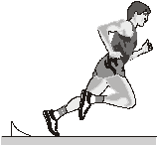
In the first 2 seconds, the athlete accelerates constantly and reaches a speed of 9 m/s.
(i) Calculate the acceleration of the athlete.
Show clearly how you work out your answer.
______________________________________________________________
______________________________________________________________
______________________________________________________________
Acceleration = _______________
(2)
(ii) Which one of the following is the unit for acceleration?
Draw a ring around your answer.
J/s m/s m/s² Nm
(1)
(iii) Complete the following sentence.
The velocity of the athlete is the __________________________________ of
the athlete in a given direction.
(1)
(iv) Complete the graph to show how the velocity of the athlete changes during the first 2 seconds of the race.
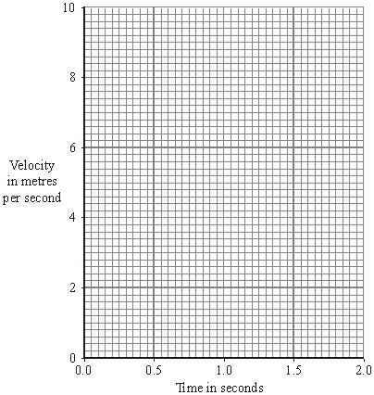
(2)
(b) Many running shoes have a cushioning system. This reduces the impact force on the athlete as the heel of the running shoe hits the ground.
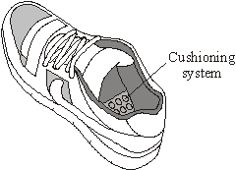
The bar chart shows the maximum impact force for three different makes of running shoe used on three different types of surface.
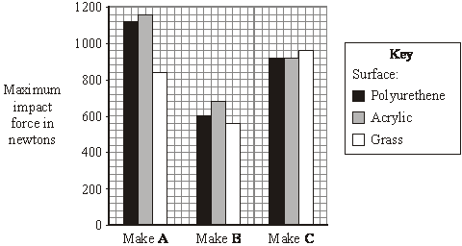
(i) Which one of the three makes of running shoe, A, B or C, has the best cushioning system?
______________________________________________________________
Explain the reason for your answer.
______________________________________________________________
______________________________________________________________
______________________________________________________________
______________________________________________________________
(3)
(ii) The data needed to draw the bar chart was obtained using a robotic athlete fitted with electronic sensors.
Why is this data likely to be more reliable than data obtained using human athletes?
______________________________________________________________
______________________________________________________________
(1)
(Total 10 marks)
Q11.
Two students investigated how the acceleration of a trolley depends on the force applied to the trolley.
Before starting the investigation, each student wrote a hypothesis.
Hypothesis of student A:
‘The acceleration of the trolley is directly proportional to the force applied to the trolley.'
Hypothesis of student B:
‘Changing the force applied to the trolley will change the acceleration of the trolley.'
(a) Consider the hypothesis of student A.
Predict what would happen to the acceleration of the trolley if the force applied to the trolley is doubled.
___________________________________________________________________
___________________________________________________________________
(1)
(b) Why is it difficult to make a valid prediction using the hypothesis of student B?
___________________________________________________________________
___________________________________________________________________
(1)
Figure 1 shows some of the equipment used by the students.
Figure 1
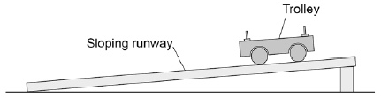
(c) Write a list of any other equipment the students will need to complete the investigation.
___________________________________________________________________
___________________________________________________________________
___________________________________________________________________
___________________________________________________________________
___________________________________________________________________
(2)
(d) Why should the students use a sloping runway?
Tick one box.

To reduce the effect of friction on the trolley. | 
To decrease the acceleration of the trolley.
To stop the trolley rolling back up the runway.
(1)
(e) Describe a method the students could have used for their investigation.
(6)
(f) The students used the same trolley throughout the investigation.
Suggest why.
___________________________________________________________________
___________________________________________________________________
___________________________________________________________________
___________________________________________________________________
(2)
The students' results are shown as a graph in Figure 2.
Figure 2
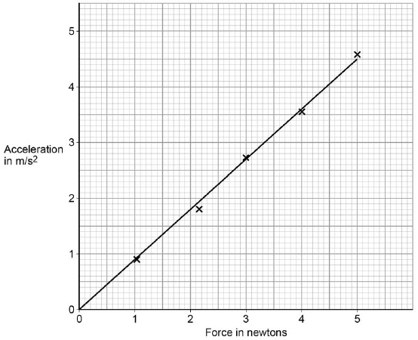
(g) Explain why hypothesis A gives a better explanation of the results.
___________________________________________________________________
___________________________________________________________________
___________________________________________________________________
___________________________________________________________________
(2)
(Total 8 marks)
Q12.
(a) The diagram shows the forces acting on a parachutist in free fall.
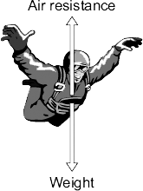
The parachutist has a mass of 75 kg.
Calculate the weight of the parachutist.

gravitational field strength = 10 N/kg
Show clearly how you work out your answer and give the unit.
___________________________________________________________________
___________________________________________________________________
Weight = __________________________
(3)
(b) In this question you will be assessed on using good English, organising information clearly and using specialist terms where appropriate.
The graph shows how the vertical velocity of a parachutist changes from the moment the parachutist jumps from the aircraft until landing on the ground.
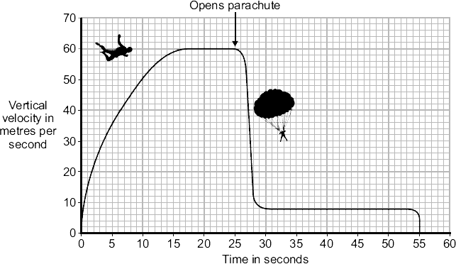
Using the idea of forces, explain why the parachutist reaches a terminal velocity and why opening the parachute reduces the terminal velocity.
___________________________________________________________________
___________________________________________________________________
___________________________________________________________________
___________________________________________________________________
___________________________________________________________________
___________________________________________________________________
___________________________________________________________________
___________________________________________________________________
___________________________________________________________________
___________________________________________________________________
(6)
(c) A student wrote the following hypothesis.
‘The larger the area of a parachute, the slower a parachutist falls.’
To test this hypothesis the student made three model parachutes, A, B and C, from one large plastic bag. The student dropped each parachute from the same height and timed how long each parachute took to fall to the ground.
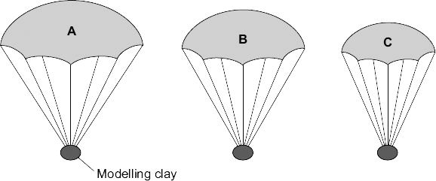
(i) The height that the student dropped the parachute from was a control variable.
Name one other control variable in this experiment.
______________________________________________________________
(1)
(ii) Use the student’s hypothesis to predict which parachute, A, B or C, will hit the ground first.
Write your answer in the box.
Give a reason for your answer.
______________________________________________________________
______________________________________________________________
______________________________________________________________
(2)
(Total 12 marks)
Q13.
A trolley is attached to two identical springs.
The trolley is pushed to the left and then released.
Figure 1 shows the horizontal forces acting on the trolley just after it is released.
Figure 1
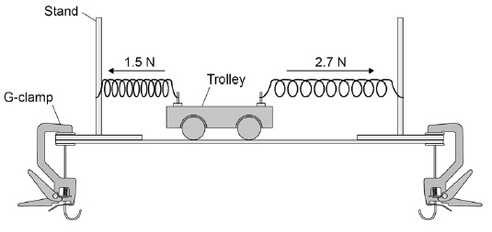
(a) Write the equation which links acceleration, mass and resultant force.
___________________________________________________________________
(1)
(b) The trolley has a mass of 0.75 kg
Calculate the acceleration of the trolley just after it is released.
Give the unit.
___________________________________________________________________
___________________________________________________________________
___________________________________________________________________
___________________________________________________________________
___________________________________________________________________
Acceleration = ____________________ Unit ____________________
(4)
An elastic cord is fixed to the trolley.
Figure 2 shows the arrangement viewed from above.
Figure 2
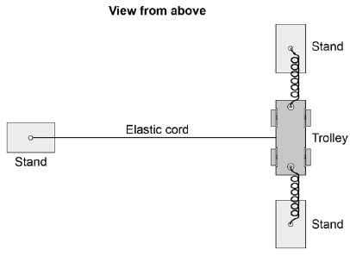
When the trolley is pushed and released a wave travels along the cord.
(c) What type of wave travels along the cord?
___________________________________________________________________
Give the reason for your answer.
___________________________________________________________________
___________________________________________________________________
(2)
(d) Suggest one change that could be made to the apparatus shown in Figure 2 to produce a wave with a lower frequency.
___________________________________________________________________
___________________________________________________________________
(1)
(Total 8 marks)
Q14.
A bus is taking some children to school.
(a) The bus has to stop a few times. The figure below shows the distance–time graph for part of the journey.
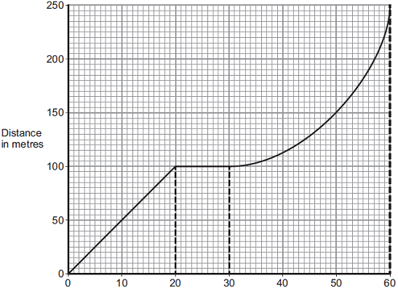
Time in seconds
(i) How far has the bus travelled in the first 20 seconds?
Distance travelled = ______________________ m
(1)
(ii) Describe the motion of the bus between 20 seconds and 30 seconds.
______________________________________________________________
______________________________________________________________
(1)
(iii) Describe the motion of the bus between 30 seconds and 60 seconds.
Tick () one box.

Tick ()
Accelerating
Reversing
Travelling at constant speed
(1)
(iv) What is the speed of the bus at 45 seconds?
Show clearly on the figure above how you obtained your answer.
______________________________________________________________
______________________________________________________________
______________________________________________________________
Speed = ______________________ m / s
(3)
(b) Later in the journey, the bus is moving and has 500 000 J of kinetic energy.
The brakes are applied and the bus stops.
(i) How much work is needed to stop the bus?
______________________________________________________________
Work = ______________________ J
(1)
(ii) The bus stopped in a distance of 25 m.
Calculate the force that was needed to stop the bus.
______________________________________________________________
______________________________________________________________
Force = ______________________ N
(2)
(iii) What happens to the kinetic energy of the bus as it is braking?
______________________________________________________________
______________________________________________________________
______________________________________________________________
______________________________________________________________
(2)
(Total 11 marks)
Q15.
A car driver sees a dog on the road ahead and has to make an emergency stop.
The graph shows how the speed of the car changes with time after the driver first sees the dog.
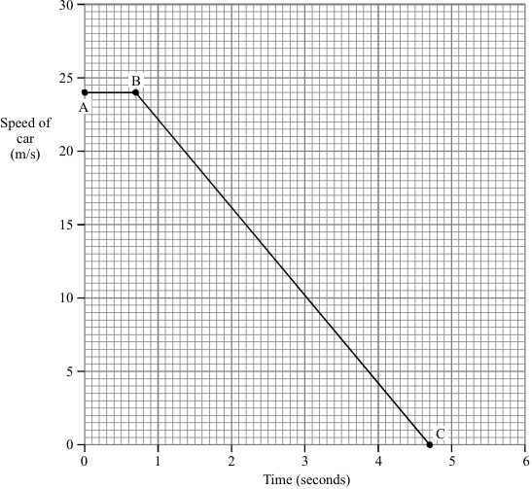
(a) Which part of the graph represents the “reaction time” or “thinking time” of the driver?
___________________________________________________________________
(1)
(b) (i) What is the thinking time of the driver?
Time ____________ seconds
(1)
(ii) Calculate the distance travelled by the car in this thinking time.
______________________________________________________________
______________________________________________________________
______________________________________________________________
Distance ___________________ m
(3)
(c) Calculate the acceleration of the car after the brakes are applied.
___________________________________________________________________
___________________________________________________________________
___________________________________________________________________
___________________________________________________________________
___________________________________________________________________
Acceleration ______________________
(4)
(d) Calculate the distance travelled by the car during braking.
___________________________________________________________________
___________________________________________________________________
___________________________________________________________________
___________________________________________________________________
___________________________________________________________________
Distance ________________________ m
(3)
(e) The mass of the car is 800 kg. Calculate the braking force.
___________________________________________________________________
___________________________________________________________________
___________________________________________________________________
___________________________________________________________________
___________________________________________________________________
Braking force ____________________ N
(3)
(Total 15 marks)

Mark schemes
Q1.
(a) W = 25 000 × 9.8
1
= 245 000 (N)
1
(b)
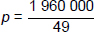
1
= 40 000
1
Pa
1
(c) B
1
(d)
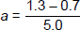
1
= 0.12 (m/s²)
1
(e)
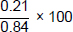
1
25%
1
(f) force (applied to the spring) = spring constant × extension
or
F = k × e
1
(g) 336 = k × 0.21
1
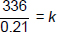
1
k = 1600 (N/m)
1
(h) v² – 0 = 2 × 9.8 × 0.95
1
v² = 18.62
allow v = √(18.62)
1
v = 4.3150…
1
= 4.3 (m/s)
allow an answer correctly rounded to 2 significant figures from an incorrect calculation which uses the values in the question
1
[18]
Q2.
(a) equal to
allow the symbol =
allow a correct answer indicated in the box provided the answer space is blank
1
(b) J -------- increasing speed
K--------- constant speed
L --------- decreasing speed
all three lines correct
allow 1 mark for 1 line correct
more than three lines are drawn scores 0
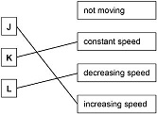
2
(c) 25 (m)
1
(d)
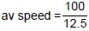
an answer of 8(.0) (m/s) scores 2 marks
1
av speed = 8(.0) (m/s)
1
OR
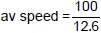
av speed = 7.93… (m/s)
allow 7.9 or 7.94
(e) 3.0
1
[7]
Q3.
(a) any two from:
• (make shape / body) more streamlined
accept a correct description
accept lower the seating position of the driver
• increase power of engine
faster engine is insufficient
• reduce mass / weight (of go-kart)
change wheel size is insufficient
2
(b) (i) A–B
reason only scores if A–B is chosen
1
steepest / steeper gradient / slope
1
(iii) 1820
allow 1 mark for correct substitution, ie 140 × 13 provided no subsequent step shown
2
[6]
Q4.
(a) 4 N to the right
1
(b) (i) bigger than
1
equal to
1
(ii) reduces it
1
increases air resistance / drag / force C
accept parachute has large(r) (surface) area
1
[5]
Q5.
(a) equal to
1
(b) deceleration / decelerate
braking is insufficient
1
(c)
1
3 (m/s²)
an answer of 3 (m/s²) scores 2 marks
allow other correct pairs of numbers taken from A to B
1
(d) the stopping distance increases
1
by more than double
1
[6]
Q6.
(a) uniform acceleration
allow constant / steady acceleration
allow velocity / speed increasing at a constant rate
ignore reference to direction
acceleration scores 1 mark
or
velocity / speed is increasing scores 1 mark
do not accept acceleration increases
2
(b) up(wards)
1
(c) a group of objects that interact
1
(d) velocity just after bounce is less than just before bounce
allow velocity is less / decreases
velocity decreases to zero − on its own scores zero
or
the height at the top of the bounce is less than the height from which it was dropped
1
so the ball has lost energy
1
correct reference to (loss of) ke or (reduced) gpe
1
total energy of ball and Earth / ground is constant
allow ‘a system’ for ball and Earth
allow energy is conserved
1
[8]
Q7.
(a) B
reason only scores if B is chosen
1
gradient / slope is the steepest / steeper
answers must be comparative
accept steepest line
ignore greatest speed
1
(b) (velocity includes) direction
‘it’ refers to velocity
1
[3]
Q8.
(a) 96
allow 1 mark for correct substitution
ie 80 × 1.2
2
newton or N
allow Newton
do not allow n
1
(b) (i) direction
1
(ii) velocity and time are continuous (variables)
answers must refer to both variables
accept the variables are continuous / not categoric
accept the data / ‘it’ is continuous
accept the data / ‘it’ is not categoric
1
(iii) C
1
velocity is not changing
the 2 marks for reason may be scored even if A or B are chosen
accept speed for velocity
accept speed is constant (9 m/s)
accept not decelerating
accept not accelerating
accept reached terminal velocity
1
forces must be balanced
accept forces are equal
accept arrows are the same length / size
or
resultant force is zero
do not accept the arrows are equal
1
[8]
Q9.
(a) (i) constant speed
do not accept normal speed
do not accept it is stopped / stationary
1
in a straight line
accept any appropriate reference to a direction
constant velocity gains 2 marks
‘not accelerating’ gains 2 marks
terminal velocity alone gets 1 mark
1
(ii) goes down owtte
accept motorbike (it) slows down
1
(b) (i) 20 (m/s)
ignore incorrect units
1
(ii) acceleration = 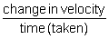

do not accept velocity for change in velocity
accept change in speed
accept 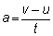 or 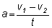
or a =
do not accept 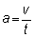
1
(iii) 4
or their (b)(i) ÷ 5
allow 1 mark for correct substitution
2
m/s²
m/s/s or ms or metres per
second squared or metres per
second per second
1
(c) vehicle may skid / slide
loss of control / brakes lock / wheels lock
accept greater stopping distance or difficult to stop
1
due to reduced friction (between tyre(s) and road)
accept due to less grip
do not accept no friction
1
(d) any three from:
do not accept night time / poor vision
• increased speed
• reduced braking force
• slower (driver) reactions
NB specific answers may each gain credit eg tiredness (1), drinking alcohol (1), using drugs (1), driver distracted (1) etc
• poor vehicle maintenance
specific examples may each gain credit eg worn brakes or worn tyres etc
• increased mass / weight of vehicle
accept large mass / weight of vehicle
• poor road surface
• more streamlined
if candidates give three answers that affect stopping distance but not specific to increase award 1 mark only
3
[13]
Q10.
(a) (i) 4.5
allow 1 mark for correct substitution i.e. 9 ÷ 2
2
(ii) m/s²
accept answer given in (a)(i) if not contradicted here
1
(iii) speed
1
(iv) straight line from the origin passing through (2s, 9m/s)
allow 1 mark for straight line from the origin passing through to t = 2 seconds
allow 1 mark for an attempt to draw a straight line from the origin passing through (2,9)
allow 1 mark for a minimum of 3 points plotted with no line provided if joined up would give correct answer. Points must
include(0,0) and (2,9)
2
(b) (i) B
if A or C given scores 0 marks in total
1
smallest (impact) force
1
on all/ every/ any surfaces
these marks are awarded for comparative answers
1
(ii) (conditions) can be repeated
or
difficult to measure forces with human athletes
accept answers in terms of variations in human athletes e.g.
athletes may have different weights area / size of feet may be different difficult to measure forces athletes run at different speeds
accept any answer that states or implies that with humans the conditions needed to repeat tests may not be constant
e.g.
athletes unable to maintain constant speed during tests (or during repeat tests)
do not accept the robots are more accurate
removes human error is insufficient
fair test is insufficient
1
[10]
Q11.
(a) double
1
(b) the hypothesis does not say how increasing / decreasing the force increases / decreases the acceleration
1
(c) appropriate equipment to apply and measure force
eg newtonmeter or slotted masses + string + pulley
1
appropriate equipment to measure change in velocity and time
eg ticker timer + tape or light gates + datalogger
1
(d) to reduce the effect of friction on the trolley
1
(e)
Level 3: The method would lead to the production of a valid outcome. All key steps are identified and logically sequenced. | 5-6
Level 2: The method would not necessarily lead to a valid outcome. Most steps are identified, but the plan is not fully logically sequenced. | 3-4
Level 1: The method would not lead to a valid outcome. Some relevant steps are identified, but links are not made clear. | 1-2
No relevant content | 0
Indicative content
• method by which the trolley is to be accelerated
• how the accelerating force is varied to give a suitable range of results
• how the accelerating force is measured
• the use of suitable apparatus to measure the change in velocity of the trolley over a given distance or time
• what data is to be collected in order to calculate acceleration
• how the data required is to be measured
6
(f) so that the mass is constant
fair test is insufficient
1
as changing mass would change the acceleration (produced by a given force)
or
so there is only one independent variable
1
(f) hypothesis A because
A must be identified to gain either mark
1
the results give a straight line that passes through the origin
showing direct proportionality
1
[15]
Q12.
(a) 750
allow 1 mark for correct substitution, ie 75 × 10 provided no subsequent step shown
2
newton(s) / N
do not accept n
1
(b) Marks awarded for this answer will be determined by the Quality of Written Communication (QWC) as well as the standard of the scientific response.
Examiners should also refer to the Marking Guidance, and apply a ‘best-fit’
approach to the marking.
0 marks
No relevant content.
Level 1 (1-2 marks)
There is a brief attempt to explain why the velocity /
speed of the parachutist changes.
or
the effect of opening the parachute on velocity/speed is given.
Level 2 (3-4 marks)
The change in velocity / speed is clearly explained in terms of force(s)
or
a reasoned argument for the open parachute producing a lower speed.
Level 3 (5-6 marks)
There is a clear and detailed explanation as to why the parachutist
reaches terminal velocity
and
a reasoned argument for the open parachute producing a lower speed
examples of the physics points made in the response to explain
first terminal velocity
• on leaving the plane the only force acting is weight (downwards)
accept gravity for weight throughout
• as parachutist falls air resistance acts (upwards)
accept drag / friction for air resistance
• weight greater than air resistance
or
resultant force downwards
• (resultant force downwards) so parachutist accelerates
• as velocity / speed increases so does air resistance
• terminal velocity reached when air resistance = weight
accept terminal velocity reached when forces are balanced
to explain second lower terminal velocity
• opening parachute increases surface area
• opening parachute increases air resistance
• air resistance is greater than weight
• resultant force acts upwards / opposite direction to motion
• parachutist decelerates / slows down
• the lower velocity means a reduced air resistance
air resistance and weight become equal but at a lower (terminal) velocity
6
(c) (i) any one from:
• mass of the (modelling) clay
accept size/shape of clay size/amount/volume/shape of clay
accept plasticine for (modelling)clay
• material parachute made from
accept same (plastic) bag
• number / length of strings
1
(ii) C
reason only scores if C is chosen
1
smallest (area) so falls fastest (so taking least time)
accept quickest/quicker for fastest
if A is chosen with the reason given as ‘the largest area so falls slowest’ this gains 1 mark
1
[12]
Q13.
(a) (resultant) force = mass × acceleration
allow F = ma
symbols must be correct
1
(b) (2.7 – 1.5) = 0.75 × a
an answer of 1.6 scores 3 marks
1
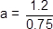
allow compensation marks for correct use of incorrect resultant force
1
a = 1.6
1
m/s²
1
(c) transverse
1
the oscillation / vibration is perpendicular to the direction of energy transfer
allow wave travel for energy transfer
1
(d) use springs with a smaller spring constant
allow use weaker springs
or
use a trolley with greater mass
allow use a heavier trolley
do not accept use a larger trolley
allow add a mass / weight to the trolley
1
(Total 8 marks)
Q14.
(a) (i) 100 (m)
1
(ii) stationary
1
(iii) accelerating
1
(iv) tangent drawn at t = 45 s
1
attempt to determine slope
1
speed in the range 3.2 – 4.2 (m / s)
dependent on 1st marking point
1
(b) (i) 500 000 (J)
ignore negative sign
1
(ii) 20 000 (N)
ignore negative sign
allow 1 mark for correct substitution, ie
500 000 = F × 25
or their part (b)(i) = F × 25
provided no subsequent step
2
(iii) (kinetic) energy transferred by heating
1
to the brakes
ignore references to sound energy
if no other marks scored allow k.e. decreases for 1 mark
1
[11]
Q15.
(a) AB
for 1 mark
1
(b) (i) 0.7
for 1 mark each
1
(ii) 16.8
gains 2 marks
2
but correct working
(d = v.t, d = 24 × 0.7, or in terms of area under graph)
gains 1 mark
1
(c) a = (v-u)/t
= 24/4
= 6
m/s²
(see marking of calculations)
(can work in terms of graph gradient)
4
(d) d = v.t
= 24/2 × 4
= 48
(see marking of calculations)
(can work in terms of area under graph)
3
(e) F = ma
= 800 × 6
= 4800
(see marking of calculations)
3
[15]

